> library(deSolve)
> library(tibble)
> library(purrr)
> library(glue)
> library(dplyr)
> library(ggplot2)
> START <- 0
> FINISH <- 20
> STEP <- 0.125
> simtime <- seq(START, FINISH, by = STEP)
> stocks <- c(sSusceptible = 99999, sInfected = 1, sRecovered = 0)
> auxs <- c(aTotalPopulation = 100000, aEffective.Contact.Rate = 2,
+ aDelay = 2)
> model <- function(time, stocks, auxs) {
+ with(as.list(c(stocks, auxs)), {
+ aBeta <- aEffective.Contact.Rate / aTotalPopulation
+ aLambda <- aBeta * sInfected
+
+ fIR <- sSusceptible * aLambda
+ fRR <- sInfected / aDelay
+
+ dS_dt <- -fIR
+ dI_dt <- fIR - fRR
+ dR_dt <- fRR
+
+ return(list(c(dS_dt, dI_dt, dR_dt),
+ IR = fIR, RR = fRR, Beta = aBeta, Lambda = aLambda,
+ CE = aEffective.Contact.Rate))
+ })
+ }
>
> o <- data.frame(ode(y = stocks, times = simtime, func = model,
+ parms = auxs, method = "euler"))
> as_tibble(o)
# A tibble: 161 × 9
time sSusceptible sInfected sRecovered IR RR Beta Lambda
<dbl> <dbl> <dbl> <dbl> <dbl> <dbl> <dbl> <dbl>
1 0 99999 1 0 2.00 0.5 0.00002 0.00002
2 0.125 99999. 1.19 0.0625 2.37 0.594 0.00002 0.0000237
3 0.25 99998. 1.41 0.137 2.82 0.705 0.00002 0.0000282
4 0.375 99998. 1.67 0.225 3.35 0.837 0.00002 0.0000335
5 0.5 99998. 1.99 0.330 3.98 0.994 0.00002 0.0000398
6 0.625 99997. 2.36 0.454 4.72 1.18 0.00002 0.0000472
7 0.75 99997. 2.80 0.601 5.61 1.40 0.00002 0.0000561
8 0.875 99996. 3.33 0.777 6.66 1.66 0.00002 0.0000666
9 1 99995. 3.95 0.985 7.91 1.98 0.00002 0.0000791
10 1.12 99994. 4.70 1.23 9.39 2.35 0.00002 0.0000939
# ℹ 151 more rows
# ℹ 1 more variable: CE <dbl>
# ℹ Use `print(n = ...)` to see more rows
> ggplot(o, aes(x = time)) +
+ geom_point(aes(y = IR, color = "IR")) +
+ geom_line(aes(y = IR, color = "IR")) +
+ geom_point(aes(y = RR, color = "RR")) +
+ geom_line(aes(y = RR, color = "RR")) +
+ labs(color = "Variable",y="system flow") +
+ scale_color_manual(values = c("IR" = "red", "RR" = "blue")) +
+ theme_minimal()

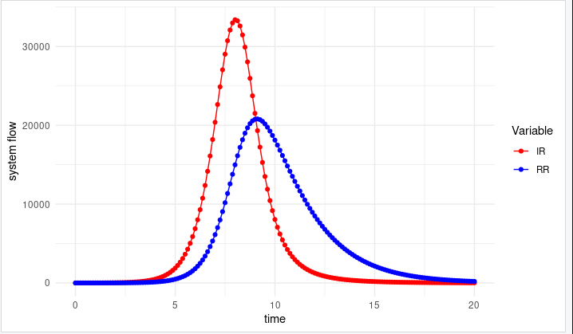

> ggplot(o, aes(x = time)) +
+ geom_point(aes(y = sSusceptible, color = "sSusceptible")) +
+ geom_line(aes(y = sSusceptible, color = "sSusceptible")) +
+ geom_point(aes(y = sInfected, color = "sInfected")) +
+ geom_line(aes(y = sInfected, color = "sInfected")) +
+ geom_point(aes(y = sRecovered, color = "sRecovered")) +
+ geom_line(aes(y = sRecovered, color = "sRecovered")) +
+ labs(color = "Variable",y="system flow") +
+ scale_color_manual(values = c("sSusceptible" = "red", "sInfected" = "blue", "sRecovered" = "green")) +
+ theme_minimal()
